DIGESTION REVISION

WACE 2014

# Question 41 (20 marks)

1. Outline the mechanical digestion of the fat found on a piece of bacon. (6 marks)
2. Outline the chemical digestion of a carbohydrate found in a piece of bread. (9 marks)
3. Describe the features of the small intestine that maximise the process of absorption.

(5 marks)

# Question 38 WACE 2013 (16 marks)

Parts (a) and (b) of the question refer to the diagram of the digestive system below.

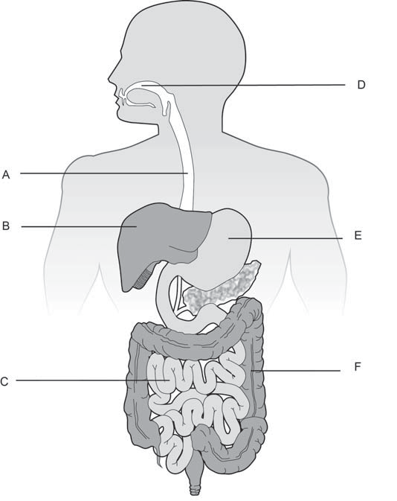

1. Identify the structures labelled ‘A’ and ‘B’. (2 marks)

A:

B:

1. Various functions of the digestive system are listed below. Match these functions with the labelled structures in the diagram above.

Some of the functions described may match more than one labelled structure. Make sure you list **all** the structures that perform that function. (4 marks)

Chemical digestion:

Chemical digestion of protein:

Absorption of nutrients and/or water:

Bile production:

Parts (c), (d) and (e) of the question refer to the diagram of the heart below.

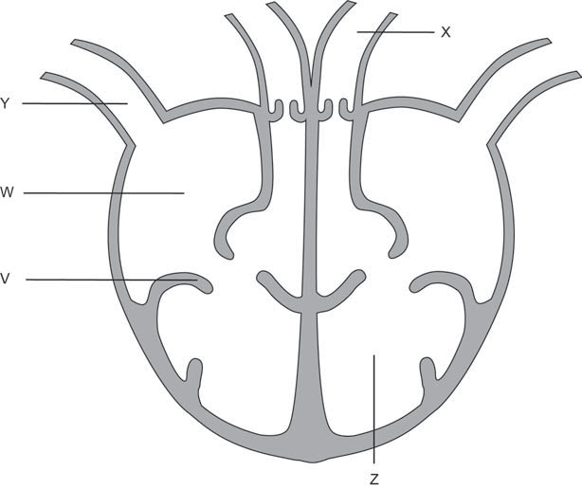

1. Identify the structures labelled ‘W’ and ‘Z’. 2 marks) W:

Z:

1. Describe the role of the structure labelled ‘V’ on the diagram. (1 mark)
2. Compare the vessels labelled ‘X’ and ‘Y’ by completing the table below. (4 marks)

|  |  |  |
| --- | --- | --- |
|  | **Vessel X** | **Vessel Y** |
| **Structure** |  |  |
| **Function** |  |  |

1. Describe **three** events in the process of blood clotting. (3 marks) One:

Two:

Three: